# ✴ Smart Waste Management

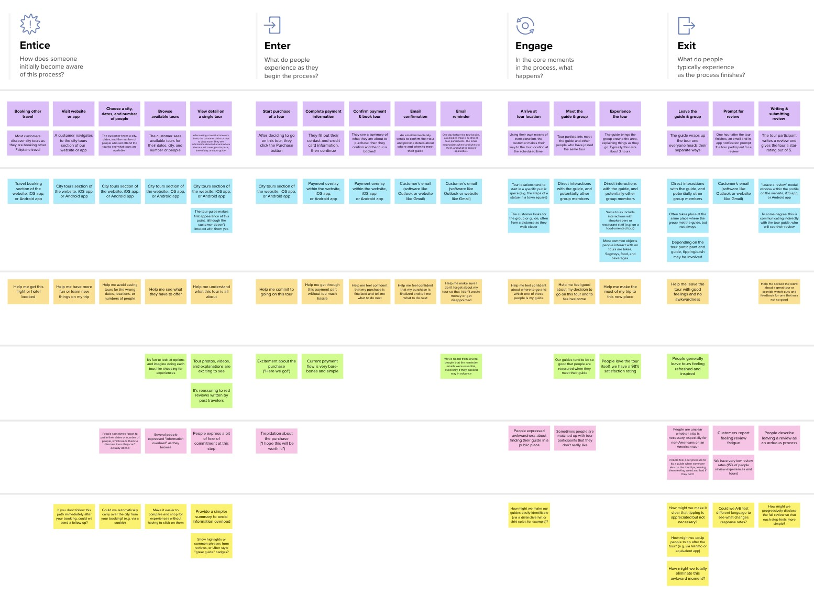

**Document an existing experience**

Narrow your focus to a specific scenario or process within an existing product or service. In the **Steps** row, document the step-by-step process someone typically experiences, then add detail to each of the other rows.

# System for Metropolitan Cities

**Team ID:** PNT2022TMID41935

**TIP**

As you add steps to the experience, move each these “Five Es” the left or right depending on the scenario you are documenting.

**Template**



Customer experience journey map

|  |  |  |  |  |  |
| --- | --- | --- | --- | --- | --- |
| **SCENARIO**  **Browsing, booking, attending, and rating a local city tour** | **Entice**  How does someone initially become aware of this process? | **Enter**  What do people experience as they begin the process? | **Engage**  In the core moments in the process, what happens? | **Exit**  What do people typically experience  as the process finishes? | **Extend**  What happens after the experience is over? |
| **Steps**  What does the person (or group) typically experience?  This is a title... | **Check The Dustbin Visit The App View The Details**  User can check the user can visit the app user Can view the Dustbin of its for checking Dustbin details of dustbin  working level and truck track and truck route | **Put The wastes Using of App Notification**  User can put the User Can Saw the When the waste is wastes in bin with Dustbin levels Full, User or Admin  clear form get the Notification | **Arrive at The Experience the**  **Dustbin Visit the app Dustbin**  User Where get to User visit the app User puts the wastes infront of Dustbin to and make a at correct time and put the wastes Clearance of puting where the waste  a wastes level can be shown | **Leave The Dustbin Review The Dusbin**  After putting The  Waste in dustbin User can review the  user leaves the dustbin to the Admin dustbin | **User Suggestion Show The City usages**  User can Know The  User can Suggest to Usage of Dustbin Admin and usage of city  wastes |
| **Interactions**  What interactions do they have at each step along the way?  **People:** Who do they see or talk to?  **Places:** Where are they?  **Things:** What digital touchpoints or physical objects would they use? | User talks about the Smartbins can be  Dustbin placed at User use the Dustbin  everywhere  User can use app for dustbin Status | Waste levels can The waste are Garbage damage or Shown to user Cleared at Right time full can be notified | user can see the truck route can  Dustbin and where waste can be shown shown using GPS  can be experience it  app can used for status level | User can put wastes user can exit from the app | user can message to waste Status are  admin about waste Shown  levels |
| **Goals & motivations**  At each step, what is a person’s primary goal or motivation? (“Help me...” or “Help me avoid...”) | Wastes can be Waste can be put Help Me to Know the Properly Collected with user Satisfaction Dustbin level | App can be used in user Interaction | Help me to Use this Help me to use App Smartbin | Waste Should collect properly at a time | Show the Dustbin Status |
| **Positive moments**  What steps does a typical person find enjoyable, productive, fun, motivating, delightful, or exciting? | User can easily Know about the Dustbin | user can easily use User know the the app Dustbin Status | Notifies when Dustbin level is full | Waste can be taken at a Time | Keeps The Practice is highly  environment clean lucrative |
| **Negative moments**  What steps does a typical person find frustrating, confusing, angering, costly, or time-consuming? | Technical Problem | App not Working | Wastes are not Properly collected | increasing cost of the dustbin | some wastes cannot be recycled |
| **Areas of opportunity**  How might we make each step better? What ideas do we have? What have others suggested? | IoT alert alert  authorized message to  person when authorized  bins get person when  Damage bin is full | Set GPS to Locate Bins and Garbage Truck | Separate Collect only  Recycle and degradable  Non Recycle and nondegradable  waste wastes | Waste Generation analysis to understand cities usages | Optimized Garbage collection route |

Use this framework to better understand customer needs, motivations, and obstacles by illustrating a key scenario or process from start to finish.



When possible, use this map to document and summarize interviews and observations with real people rather than relying on your hunches or assumptions.



Created in partnership with

[**Share template feedback**](https://muralco.typeform.com/to/CiqaHVat?typeform-source=app.mural.co)

**Need some inspiration?**



See a finished version of this template to kickstart your work.

[**Open example**](https://app.mural.co/template/f59f644b-b4b4-47b5-9ed6-3a8c71ceb612/896b31fe-5597-40ef-9b06-3811a1a45ace)